Advisors, Cadets and Explorers,

It’s Time!!! The 2024 Chandler Cadet Tactical Competition is coming up!! We are so excited to be back and bringing you the best event!!!

For our returning teams, we look forward to seeing you again. For those who have never been, you are in for an experience that will leave you counting the days until the next year. The Chandler Tactical Competition is unique in that several our events are group oriented and require a team to really come together to be successful.

Registration will open on September 5th. There will be no refunds after December 2nd, as we will be 100% responsible for all event costs at that time. All refunds prior to that date will have a $250 cancellation fee due to incurred costs prior to the competition start. Event costs are determined based on how many guests we anticipate prior to that date.

In order to streamline the process on our end, ALL registration forms and payment receipts MUST BE SCANNED AND EMAILED to us in order to get registered. Online payment is preferred. Follow the instructions at the end of this document. If you are paying by check however, please scan a copy of the completed check and include that in your email as well. Once all registration forms and payment receipts are received by email, you will be considered registered. The date/time on the email received will be used to lock in your registration position. Any questions about this process, don’t hesitate to contact me directly.

Events will be scheduled on a first come - first serve basis as usual. The first 50 teams registered will be guaranteed a spot; all others will go on a waiting list. In addition, the first 25 teams to register and pay in full will be guaranteed their top five event choices.

We look forward to hosting you at another incredible competition experience! Please call if you have any questions.

Officer Noah Dueker
Chandler Police Cadets
Mail Stop 303S, PO Box 4008
Chandler, AZ 85224-4008
Office: 480-782-4962
Email: noah.dueker@chandleraz.gov
Instagram: @CPDcadets
Twitter: @CPDCadets
Facebook: www.facebook.com/ChnPDcadets

2024 Chandler Tactical Competition
Registration Form
*Agency Name:
*Advisor Name:
Mailing Address:
City: |  |  |  |  |  | State: |  | Zip:
Advisor Office Phone:
*Advisor Cell Phone:
*Advisor Email:

E-Mail all registration documents to police.cadet@chandleraz.gov
PREFERRED - Paying by Credit Card:
Pay using the link on our TacComp Webpage and include a copy of your receipt with your registration documents you scan/email or mail to us.

[Type a quote from the document or the summary of an interesting point. You can position the text box anywhere in the document. Use the Drawing Tools tab to change the formatting of the pull quote text box.]
Cadet/Explorer Advisors
Registration Cost
_____ Cadet/Exp. @ $125/ea: $_________
_____ Advisors @ $75/ea: $____________

Total Registration Cost: $__________

Shirt Order

Please indicate how many of each size is needed for your Post. NOTE: If you list more shirts than you have participants paid, we will deduct shirts from smallest size to largest. If you do not list enough shirts for participants paid, we will add Extra Large size shirts to meet your paid numbers.

Small |  |  | Small
Medium |  |  | Medium
Large |  |  | Large
Extra Large |  |  | Extra Large
2X Large |  |  | 2X Large

26th Annual Chandler Tactical Competition
Registration Form

Team Name: ______________________________________________________

Please assign numbers (1-14) next to each event to indicate your order of importance.
For example, “1” next to the event you wish to do most, and the final number next to the event you wish to do the least. If there are events you do not wish to participate in at all, please place an X on the line.

Remember, the first 25 teams to register and pay will be guaranteed their top five choices!

 | 5 Man Hostage Rescue |  |  | Virtra Decision Shoot
 | Terrorist Takeover |  |  | SWAT Technical Support
 | Crisis Negotiations |  |  | Sniper Challenge (Live Fire)
 | Downed Officer Rescue |  |  | SWAT Fitness Challenge
 | Unknown Alarm Response |  |  | Tactical Emergency Medicine
 | Narcotics Raid |  |  | Technical Support Response
 | Pistol Shoot (Live Fire) |  |  | High Risk Vehicle Stop

ALL EVENTS ARE SUBJECT TO CHANGE WITHOUT NOTICE

PAYMENT INFORMATION:
Follow the link: https://www.invoicecloud.com/portal/(S(00e12v14cjhzf1rnpkuyjhth))/2/cloudstore.aspx?cs=8690F1E2-F3A4-4C70-A489-0DFEED2F5EBE&bg=4ff697cb-92a2-4903-9bbe-da8a4f5eeb20&return=Site.aspx%3FG%3Db8da3acf-ae3d-4293-b769-257e8ba694ee
This will bring you to the City of Chandler Secure Payment Portal.

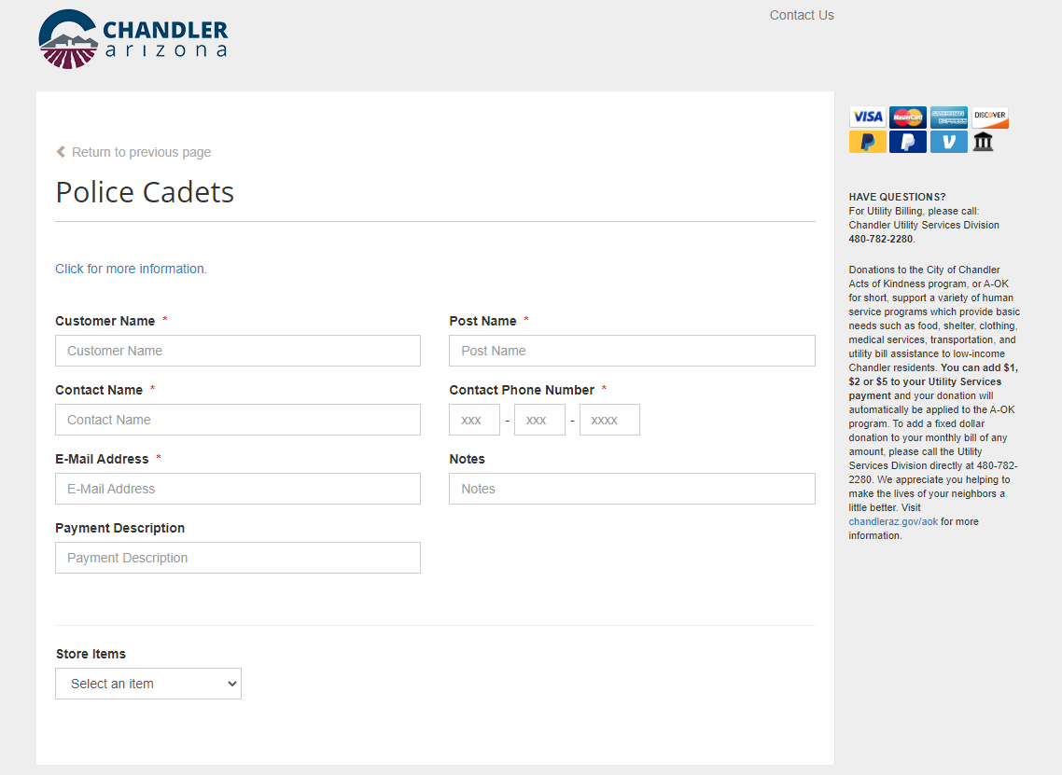
Please fill out the information completely. Customer Name is the person paying the fees.
Post Name is your Cadet/Explorer program name.
Contact Name, Email Address and Phone Number is for the Lead Advisor who will be attending the event.
Payment Description is Tactical Competition 2024

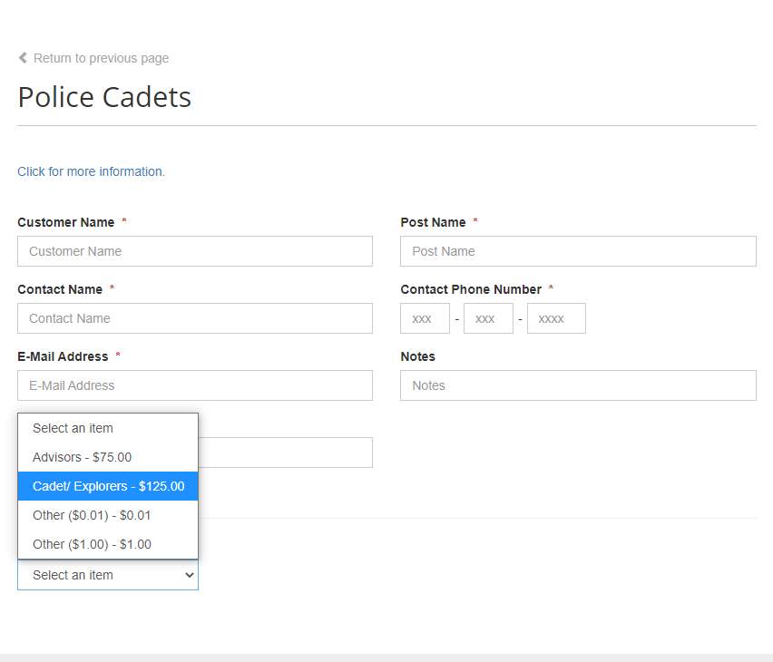
Under Store Items, select Cadet/Explorers and the quantity you are paying for.
Next click “Add to List” and then select Advisors and the quantity you are paying for. Click “Add to List”.
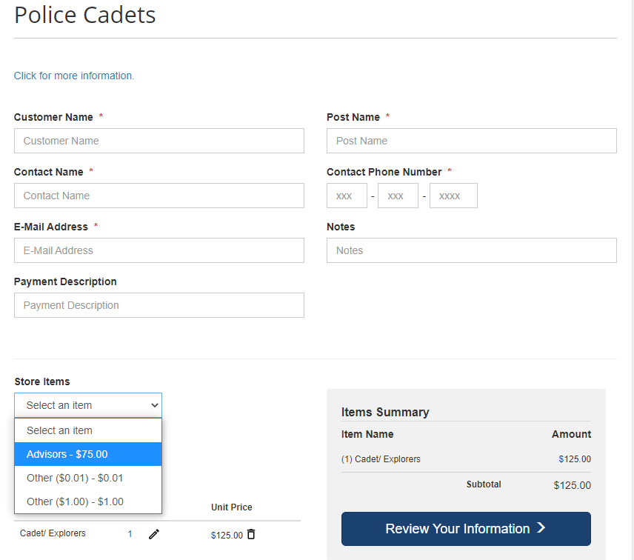

Finally, click Review your Information and go to the payment page and follow the steps.
Any questions, don’t hesitate to contact me directly.

