chandler police department
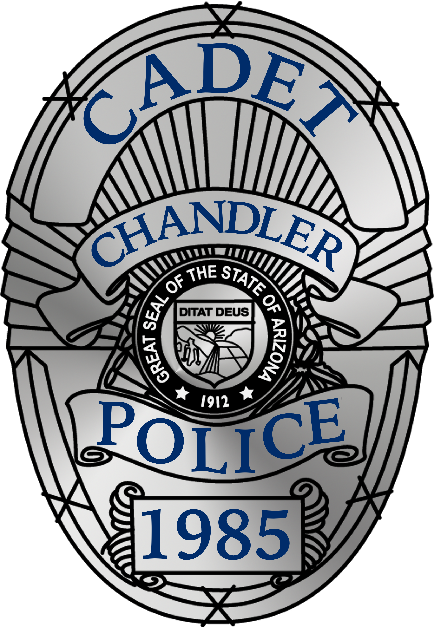
26th Annual Chandler Tactical Competition
January 13-14, 2024

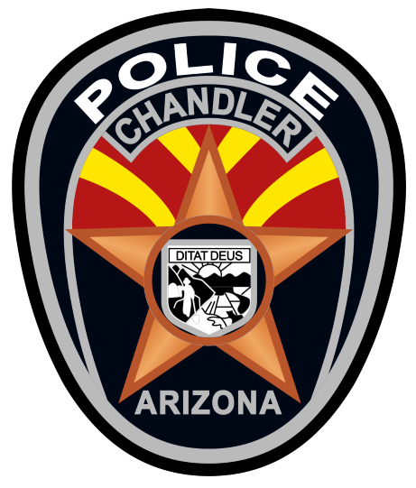
Contents
Welcome Letter 3
Registration, Check-In & Closing Ceremonies. 4
Weather 5
Uniforms 5
Meals 5
Downtime 5
Parking 5
Day Camp 6
General Rules 6
All Tactical Events: 7
Carlos Ledesma Team Spirit Trophy 8
Evaluation Criteria 10
Event Descriptions 11
5-Man HRT 11
Terrorist Takeover 11
Crisis Negotiations 11
VIRTRA Decision Shoot 11
Hogan’s Alley Error! Bookmark not defined.
3 Mile-ish Run 11
Drug Lab Raid 11
Downed Officer Rescue 12
Obstacle Course 12
Pistol Shoot 13
Sniper Challenge 13
Rapid Response 14
Robot Operations Error! Bookmark not defined.
Tactical Relay Race 14
Tactical Manhunt 14
TK-4 Pull 14
SWAT Fitness Challenge 14
Tactical Emergency Medical Support (TEMS) 15
High Risk Vehicle Stop 15
Vertical Assault 15
Laser Tag Error! Bookmark not defined.

Welcome Letter

September 12, 2023
Welcome Directors and Advisors; Competitors and Cadets. This year marks the 25th year for the original Chandler TACTICAL COMPETITION. To our returning guests, we are honored that you have enjoyed our competition and decided to return. To those of you joining us for the first time, we are excited to welcome you to Chandler, and hope to provide an experience you will not soon forget!
Registration documents are now on our website, so you can print what you need. When filling out the documents, please remember to print in legible block lettering to ensure you are registered for the events you desire. We are happy to take your phone calls and emails with any questions you may have.
Return only your Program/Post registration form with your payment to Police.Cadet@chandleraz.gov by December 2, 2023.
All other documents, including liability waivers, will be scanned and emailed to us at a later date… Instructions for that will come later.
We wish you all safe travels, and look forward to seeing you in January!
Chandler Police Department
Tac-Comp 2024 Staff & Judges

Mailing Address:

Officer Noah Dueker #608
Police Cadets Coordinator
Chandler Police Department
Mail Stop 303S, PO Box 4008
Chandler, Arizona 85244-4008

Noah.dueker@chandleraz.gov
Office: 480-782-4962

Registration, Check-In & Closing Ceremonies.

Registration for the 25th Annual Chandler Tactical Competition needs to be completed prior to your arrival. Complete the Registration Form provided on our website, scan and email it to us with your final payment information. The Chandler Tactical Competition accepts Credit Card payment and the link is posted on our website.

You should receive an email from us when we receive your registration payment. You are welcome to call or email Officer Quinn at any time to check your status. Please bear in mind the Fall months are our busiest months for community service, so email may get a quicker or timelier response.

Important Dates:

Nov 4, 2023 – Last day to pay in full and guarantee agency place in competition & attendee gifts
Dec 2, 2023 – Refunds on cancellations no longer available (-$250 cancellation fee)
Jan 13, 2024 – Advisors check in at 0730, Full Day of Competition. 0900-1800. Dinner served at 1800
Jan 14, 2024 – Final day of competition, All events close at 1500.
Closing ceremony begins at approximately 1630.
Jan 15, 2024 – Don’t Forget – Monday, January 16 is the MLK Holiday

**Advisors Only** Check-In will be at 0730 on Saturday Jan 13th. Please report to the amphitheater at the Public Safety Training Center. We will brief all advisors at once and hand out schedules. We will not be doing check-in at the hotel this year!!

At Check-In, you will need to complete the following steps:
- Ensure you Post is paid in full for the competition
- Confirm you have turned in a Participant Waiver for each person (Advisors and Participants)
- Provide on-site advisor contact information
- Collect a wrist band for each participant (Advisors and Participants)
- Collect your promotions bag with t-shirts, etc

  - Closing Ceremonies
The Chandler Tactical Competition provides its participants with some of the most awards possible. To that end, closing ceremonies can take a long time. In an effort to keep things moving, there will be some guidelines as it relates to receiving awards.

When called as a place winner in an event, each Program is asked to send no more than two participants to receive their award. Chandler Police photographers will be on site to take photos, and they will be posted within two weeks of the competition.

We will provide a location to use at the end of closing ceremonies for any photographs you wish to take on your own. The Chandler Police Command Staff, our Judges, other honored guests and I will remain to be a part of any pictures you wish to take.

Don’t worry about committing this to memory now, I promise to review it with you at closing ceremonies.

Weather
Arizona weather in January: Average monthly rainfall .67”, Monthly sunshine 78%, Daily average high 65.9 degrees, Daily average low 41.2 degrees, Monthly mean temperature 53.6 degrees, Daytime temperatures can range between 50 and 70 degrees. Occasionally we have a cold winter, and temperatures can get down into the 30’s at night. In case of extreme rain, some of the outdoor events may have to be cancelled, although this is not likely. The team in first place at the time of the cancellation will be declared the winner.

Uniforms
We always get asked what uniform(s) competitors should wear. We don’t require any special uniform, but most teams wear a BDU style uniform, or BDU pants with a t-shirt to compete. Many teams bring a patrol uniform or even a dress uniform to wear for closing ceremonies, but based on time constraints this is not mandatory. Judges will NOT judge you on uniforms or equipment.

Meals
We will provide a dinner for everyone on the Saturday evening of the competition as part of your entry fee. Other than that, you are on your own. Our Chandler Fire Department Cadets will sell breakfast and lunch on site. Finally, there are also several eating establishments a short drive away.

Downtime
Downtime is a natural part of every competition. Many of our events are scheduled to help you plan your day, but to give you something to do during down time, we have several walk-up events, the geo-tactical pursuit and other activities to keep you busy. Fun “Yard Games”, a DJ and our famous Tac-Comp store is available as well. Maps will be provided at check in for all events and locations as well as a mobile link to maps and other competition data.

Parking
The parking lot at the Public Safety Training Center is not the largest. Please plan on limited parking and agencies being limited to one or two vehicles at the competition site.

Day Camp
For those not familiar with our competition or our day-camp option, we have a designated area to drop your trailer, set up an easy-up and have a little base of operations. Please note that there is NO OVERNIGHT CAMPING at the Chandler Fire Facility. No competitors are allowed on the competition grounds after the final event closes and before 0600 hours. Please coordinate with Detective Tami Gray ahead of time (By Jan 6th, 2023) if you would like to set up a day camp. (Tami.Gray@chandleraz.gov)

General Rules

1. Advisors should ensure that dummy weapons are not displayed outside the immediate area of the competition. This should reduce our department’s ‘subject with a gun’ calls.
2. Unruly or disorderly participants will be asked to leave the competition. While in the City of Chandler, participants are expected to abide by all city and state laws. You represent not only your Agency, but Law Enforcement as a whole.
3. Participants are not to be disrespectful to ANY officer, participant, or event official. Any violation may result in immediate expulsion from the competition. Please stress this to your Competitors!
4. Participants who are scheduled for events are to be on time. Those who are late will miss their turn to compete. Five minutes is the maximum amount of time a judge will wait for a competitor or team.
5. Spectator areas may be sectioned off at many of the events. Participants should not enter into the competition area without permission of the judge. Barricade tape will mark many of these areas.
6. Every registered participant will be issued a wristband. This must be worn at ALL TIMES. No persons will be allowed to be on the grounds or participate in events, or the dinner, without their wristband on. Competitors and Advisors are the only people allowed on the Training Center property during the event. If your Supervisor/Chief/Sheriff wishes to attend or watch, they are more than welcome, please just notify Officer Quinn for credentials. Other spectators (ie: Family, Friends) are prohibited.
7. Keyword to stop any scenario is “PAIN!" If you are injured, yell pain to stop the scenario. Suspects may use this same keyword. If you hear the word “pain” then immediately stop what you are doing and wait for further instructions from the judge. Any violations of this provision are grounds for Immediate Disqualification from the event or the competition. Please stress this to your participants as all of our actors are volunteers, and physical harm to them is something we would like to avoid.
8. Occasionally rain does fall in Arizona. In case of extreme rain, some outside events may be postponed or canceled for safety reasons. All efforts will be made to complete the events as scheduled. However, if rain does cancel an event, the team in first place at the time of the cancellation will be declared the winner.
10. All registration fees are transferable, but not refundable after the deadline. If a participant is unable to show for the competition, substitutions may be made, however no fees will be refunded.
11. Complaints, protests and general dissatisfaction with a judgment or decision must be taken to the Coordinator of the Chandler Police Department Program, Officer Kevin Quinn. All decisions by the Coordinator or his designee are final.
12. There are no cooked food sales or service by anyone other than the Chandler Fire Cadets or the contracted dinner company. This is for several reasons. The most prominent is the Chandler Fire Cadets sell burgers and such as a fundraiser for their program (and we are using their property too…). Also, the Chandler Fire Cadets have already gone through the necessary processes of getting a sales license in Chandler as well as Food Handlers cards from Maricopa County. We imagine a special note from the Maricopa County Board of Health is not something you want to take home to your agency.

All Tactical Events:
1. Firearms – No real firearms which can expel any kind of projectile are permitted. Colored simulated weapons are preferred (ie ‘red guns’). Firearms used in the competition must be obviously inert and/or must be marked to indicate a non-working firearm. Some Events may have a limited number of dummy weapons available, however, these are not guaranteed, and Posts are encouraged to bring their own if they have them. Fingers are appropriate if properly holstered when not needed and un-holstered when needed (in other words, weapons cannot appear out of the air, you must simulate retrieving and holstering).
2. Grenades - Smoke, Distraction Device, Gas. If a team feels that they may need one or more of these devices, they are required to let the judge know at briefing. Dummy grenades may be provided at that time. No other grenades will be utilized. If one of the dummy gas grenades is deployed, the team must wear gas masks for the remainder of the scenario. If your team decides to deploy a Flash-bang grenade, then they must yell “FLASH” loud enough for both the Judge, and any actors in the area to hear.
3. Other Explosives - Strictly prohibited. No team will use firecrackers, smoke bombs or other incendiary devices. Advisors ensure that these items are left at home.
4. Radios - Teams may use their own radios if desired, no radios for scenarios will be provided.
5. Advisors may attend the briefing but may not communicate with the competitors until after the scenario is completely over. Nods, grunting, and pointing are considered communicating. If a advisor wishes to video tape the scenario, they may ONLY do so with the prior permission of the judge and ONLY from positions the judge allows. Violations may result in immediate disqualification. Advisors are also PROHIBITED from “pre-viewing” any events as this might be construed as giving their team an unfair advantage.
6. Shots - Any shots fired by suspects or officers (Competitors) must be accompanied by the word “BANG” (excluding events we provide a projectile weapon). This must be loud enough for all to hear. In addition, the barrel of the dummy weapon must be pointed appropriately. A weapon pointed at the floor at the time of the word “bang” will not be considered as a valid hit.
7. Deemed Shot - Once the judge has deemed that an Officer (Competitor) has been shot; the officer must lay down right where they are and not move. They may not communicate with anyone other than the judge until after the scenario is over unless approved by the judge. Downed Officers may be part of the scenario, and the team must act accordingly. Arguments about actually being shot will result in the immediate loss of another team member.
8. Orange/Yellow/Red/Green Traffic Vests - Anyone wearing a traffic vest is considered not part of the scenario and should be completely ignored. All others are considered part of the scenario.
9. Talking to the judge - Don’t. Do not simulate anything or tell the judge that you are simulating anything. If you are doing something, then do it. Unless specifically instructed by a Judge, telling the judge “I would do this, now…” is a violation of this rule.
10. Impact Weapons - There is no reason for any type of impact weapon. Competitors will not need batons, extended flashlights, OC spray or similar devices.
- Barricade Tape - Some areas of the competition will be marked with yellow barricade tape. Do not enter these areas. Areas inside the tape are NOT part of the scenario. Violating areas that are restricted by crime scene tape may result in loss of spirit coins.

Carlos Ledesma Team Spirit Trophy

The coveted “Team Spirit Trophy” is awarded to the team who collects the most spirit coins over the entire weekend. This award was renamed after Chandler Police Narcotic Detective Carlos Ledesma was killed during an undercover drug operation in 2010. Carlos was a supporter of our Cadet Program and a member of the Chandler Police Department Special Assignment Unit/SWAT tactical team. His work ethic, dedication and spirit are well represented in the meaning of this award.
1. All of the judges will have spirit coins to give out at their own discretion.
2. Several Chandler PD officials will have spirit coins to give out at their discretion too.
3. There will be several other unknown individuals who will have spirit coins. These may or may not include Hotel/Motel managers or employees, waitresses, city officials, members of the press and others.
4. Teams may receive spirit coins for showing team spirit, for doing an outstanding job in a particular area, overall politeness, cheering on other teams or members of your own team. Sometimes you could get a spirit coin for simply having a good attitude!
5. Team members should bring their coins to the Command Post where they will find a container marked to identify their Program. Coins should be deposited into the container. Team members may not pick-up and shake the containers. In fact, other than depositing coins, team members should not touch the containers.
6. At the end of the weekend, prior to closing ceremonies, the coins will be counted in each container. The team with the most coins wins the Spirit Award. There is no second place. All coins MUST be deposited no later than 1430 hours on Sunday afternoon.
7. There is No Solicitation for Spirit Coins! Any program offering assistance, to perform a task/function or in any other way communicating a willingness to perform an action for a spirit coin may have coins removed from their container.
How to win this trophy:
- Be polite to everyone you meet, including your own team members.
- Be a good sport about competition.
- Spend time with other posts, sharing information in a positive manner.
- Give both good and bad comments in a constructive manner.
- Show pride in your own post; support your own team members.
- Participate in as much as you can during the competition, be seen!

It's hard to make an overall trophy for a competition where teams vary in size from 5 to 20 and expect every program to compete equally for the grand prize based on standings in competitions alone. That is why we developed this system for the overall winner. A team of 5 can certainly compete against a team of 20 in this system.
That's how you win the team spirit trophy; it's not the team that places the highest in every event. Your team could win even if they don't get any other trophy. Please discuss these guidelines with all participants beforehand so that your team can take home this trophy!
What does the winner receive?
Other than the most prestigious trophy of the competition, the winner of the Carlos Ledesma Team Spirit Trophy gets to return the following year with no registration fees for up to ten Competitors and two Advisors. This will be arranged through the Coordinator of the Chandler Police program.

Evaluation Criteria

Participants in the Chandler Tactical Competition will be evaluated on a number of criteria to establish a winner for each event. These criteria may include some of the following. When preparing for this competition, please keep these in mind to score the most points possible.

Participants may ask questions about the evaluation criteria prior to the beginning of any event briefing. Once a briefing has begun, questions may only be asked to clarify the information being shared.

Criteria may include, but is not limited to:

- Pace/speed of competition
- Overall plan and execution of mission including contingency plans
- Safety, muzzle control and use of cover/concealment
- Time to complete event
- Communication and teamwork between team members
- Identification of threats or threat areas
- Actions taken against threats
- Decision making
- Command Presence
- Leadership

The Chandler Tactical Competition events are coordinated and judged, almost entirely, by members of our SWAT team. All of our officer/tactical operators are trained locally in techniques recognized nationally. Our judges will evaluate your actions based largely on their own training and experience. The primary organization our Agency and Judges draw training from is the National Tactical Officers Association and Arizona Tactical Officers Association. Judges do keep in mind there is more than one way to handle situations safely, but in the end, the decisions of the Judges are final and will be supported by the coordinator.

Event Descriptions

5-Man HRT
Competitors will respond and handle a threat of one or more hostages with a team of no more than five persons. Competitors must bring their own equipment/gear to handle the scenario.

Terrorist Takeover
Competitors will respond and be met with an exigent circumstance or execute a warrant with a team of no fewer than six persons, and no more than ten persons. Competitors are responsible to bring the necessary gear/equipment to resolve the scenario.

Crisis Negotiations
Your team will respond to an established communication location for negotiations. You will be briefed by the Negotiations supervisor. You have a time limit of 40 minutes for your 4-6 person team to successfully negotiate a resolution. You are responsible for your own note taking devices.
Our CNT personnel asked to inform you the digital system they use for their event allows for digital recording. If you wish to bring a digital recording device, you may plug into their system and record your competitor’s conversations.

VIRTRA Decision Shoot
Participants will compete in a decision-making shoot/don’t shoot on our new VIRTRA firearms system. Your thought process, decisions, command presence, judgment and any shot placement – just to name a few – will all be evaluated to determine a winner.
This is a walk-up event.

Unknown Alarm Response
Team members will respond to a Burglary Alarm at a local business and act accordingly to whatever happens. Even though this is a patrol based scenario, you must remember to keep a Tactical Mindset. Two officers will initially respond but backup is always just a request away.

3 Mile-ish Run
Yup… That pretty much describes it…
We say ‘ish’ because this isn’t a certified course and anything can change at the last minute like road construction and such. The course will be as close to 3 miles as possible.

Narcotics Raid
Your agency Narcotics detectives have called on you to serve a warrant for them. Specific details will be provided at the briefing.

Downed Officer Rescue
In public safety, preparing for things to go wrong is an unfortunate part of the job. In this event, you will need to recover an officer who has gone down in the line of duty.

Obstacle Course
This event is to test the physical fitness of Competitors and Mentors. This event is held at the main site with a course specifically designed for this competition. In addition to the types of obstacles one might expect, additional instructions and rules will be provided before your run. Remembering key details and being physically fit are key if you want to be a member of a tactical team.

This is a walk-up event

HIGH SEVERITY / EXTREME IMPORTANCE
NO LIVE WEAPONS ALLOWED IN RANGE AREA EXCEPT FOR THE ONES PROVIDED!! THIS INCLUDES ADVISORS!!

The Chandler Police Range Staff has complete control and authority over these two events and the safety rules/regulations they have put in place for the event are non-negotiable.

The Chandler Police Department operates a Frangible Lead-free range, and we intend to keep it that way. All ammunition will be provided at event check-in by range staff. No other ammunition will be allowed.

TRAINING NOTICE:
Program leaders, please make note of the following important points, they are CRITICAL:

- All Competitors must know, and be able to recite, the 4 rules of firearm safety
- Read the Pistol Shoot/Sniper Challenge Waiver carefully
- Advisors must sign the Pistol Shoot/Sniper Challenge waiver indicating their youth know what they’re doing

Competitors MUST arrive at the range a few minutes early, AND wearing their wrist bands. Wrist bands for competitors in this event will have control numbers on them which correspond to their waiver forms kept at the Competition Command Post. Range staff will verify competitors are wearing an appropriate wrist band on arrival.

Pistol Shoot
This event is in our indoor pistol shooting range. Guns will be provided to competitors for this event.

The targets will be mounted on turning target stands, and Shooters will engage both single and multiple targets as the targets face the shooter. Each program may have the following shooters:

- One Male Advisor
- One Female Advisor
- Two Competitors – Male, Female or one of each

Sniper Challenge
This event tests your ability to deploy as a two-man sniper detail. The weapon system used in this event will be an AR-15 with Optic and the event will be held in our indoor 50 yard rifle range. Bring with you any other gear you feel you will need. Be prepared for a potentially fast paced event requiring quick movement, an elevated heart rate and the ability to calm yourself for the critical shot.

Rapid Response
Most tactical operations teams are often forced to respond to rapidly evolving situations, without much advance notice of where they are going or what to expect. In this scenario, you must do the same. Locations for such events can include schools, office buildings or malls. You will be briefed once on scene.

SWAT Technical Support
Competitors will be dispatched to a support mission where they will have the opportunity to utilize Law Enforcement robotic devices maintained by the Chandler Police Department SWAT Team Technical Support Element to accomplish a specified mission.

Tactical Relay Race
The relay race is designed to test your efficiency in a physical obstacle event while working as a team. This is a five person event requiring each member take a turn at carrying a moderately heavy object, and the team then carrying one member across the finish line.

Tactical Manhunt
Not all situations occur in buildings or involve your standard automobile. The Tactical Manhunt event tests your team’s ability to safely search for a dangerous armed suspect in an open area.

TK-4 Pull
Strength can easily become a factor in tactical events. In fact, overall strength of your entire tactical team can be a factor in the overall success of your mission. So let’s test your team’s strength in a 5-Man or 10-Man TK-4 pull. You must have one female participant in the 5-Man, and two in the 10-Man.

SWAT Fitness Challenge
The SFC is designed to test the physical and mental stamina of the competitor. When the tough really gets going, will you? Only the MOST FIT of participants should attempt to accept this challenge. Physically demanding tasks may include:
- Run up to 1 mile  - Sprint up to 200 yards  - Climb a rope  - Lift at least 75 pounds off the ground  - 20 or more push-ups (various types)  - 50 or more sit-ups  - 10 or more pull-ups (various types)  - Press at least 50 pounds over head | - Carry up to 100 pounds for up to 100 yards  - Run up and down stairs under exertion  - Pull / Push / Flip large tire up to 50 yards  - Jump a six foot wall  - High crawl / Low crawl  - Fireman carry partner  - Swing a ram and/or sledge hammer  - Work as a team

Jumping out of an airplane, holding your breath for three minutes and hog tying an alligator were eliminated as potential event components due to liability reasons.

We’re not kidding – This is a TOUGH event. We encourage you try, but don’t complain if it is too much.

Tactical Emergency Medical Support (TEMS)
Your Six – Eight person element consisting of at least two medics and two tactical operators will be dispatched to an exigent medical recovery mission. This will test your skills in more than medical support. Be ready, the life you are saving may be your own. All medical supplies necessary for the event will be supplied. You may supplement this with your own equipment (which must be inspected). A basic understanding of in-field trauma treatment will be key to your success.

High Risk Vehicle Stop
The threat level is HIGH. Patrol officers have a vehicle stopped and have requested assistance. Competitors will be tasked with taking control of a suspect vehicle without any injury to potential victims or bystanders.

Vertical Assault
Your target has been identified and it is above you. Your four person team must scale the rock wall in the fastest time to achieve victory.

This is a walk-up event.

